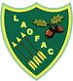
L.A.O.F.A.C.
Leicester Ancient Order of Foresters Archery Club

WA18m Tournament

(UK Record Status Open)
Part of the Countesthorpe Triple (https://www.the-foxes.org.uk/)
Brockington Community College,
Blaby Road, Enderby, Leics LE19 4AQ
on
Sunday 18th January 2026
Open to recurve, compound, longbow & barebow archers
Assembly:
Session A: 9.00 am followed by 2 ends of practice
Session B: 12.00 noon followed by 2 ends of practice
Session C: 3.00 pm followed by 2 ends of practice
Lady Paramount: TBA
Judge-in-Charge: Janet Short
Judges: Bernie Dicks, Kerry Knight
Entry Fee : £13.00
Double : £24.00
Target Faces: Compounds: Vertical Triple
Recurves: Single (see note 4)
Longbows, Barebows & AFB: Single

Our preferred method of entry is online at www.laofac.co.uk (with payment via Direct Debit from your bank account), alternatively you can email this form to tournaments@laofac.co.uk and request our Bank Details to make a BACS payment.

Tournament Organiser : Neill Brown

Tel. 07857769871 e-mail: tournaments@laofac.co.uk

Closing date: Fri 2nd January 2026, or when full.
No refunds after the closing date. Late entries may be accepted online.

Event sponsored by Merlin Archery

Notes
1. | All archers must be affiliated to Archery GB or a WA member organisation and will be asked to produce their membership cards when signing in.
2 | 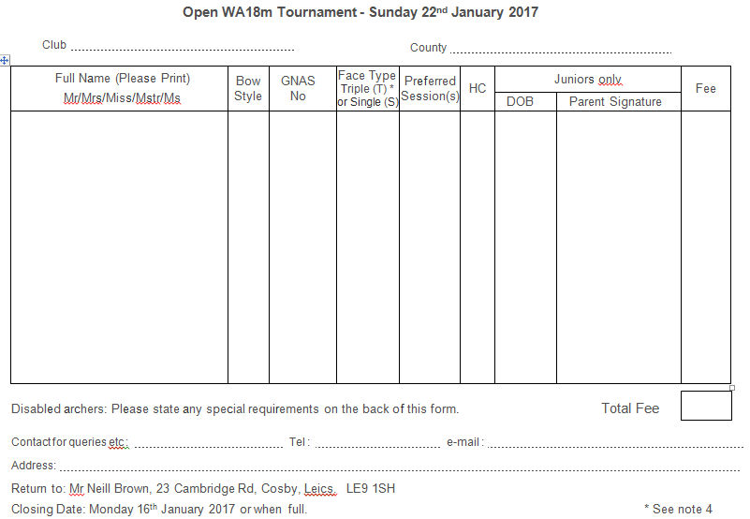  Dress Regulations in accordance with Archery GB Rule 307 apply.
3. | Final Target list posted on the day. Results will be emailed to addresses as given on the entry form and posted on the club website (www.laofac.co.uk).  Provide an SAE of suitable size if you want a hard copy and scoresheets returned. A map of the venue can also be found on the website.
4. | Recurve archers wishing to shoot on a vertical triple face should indicate this on the entry form. Allocation will be subject to availability.
5. | Archers using a wheelchair/standing support please state on the back of the entry form whether Left or Right Handed; and any other special needs.
6. | Score awards for all classes.  Club Team Awards for recurves (4) and compounds (3) which must be of mixed gender and may include juniors. Longbow teams (3) may be of any gender and age. Awards for Double will subject to entries.  HC group medals for highest unrewarded seniors and/or juniors may also be awarded subject to entries.
7. | Current HC's should be notified to the organiser before sighters.
8. | Record status shoots are liable for drug testing. Competitors approached to give samples must comply. A refusal will be treated as a positive result.  A Parent or Guardian must sign the entry form for consent to Junior drug testing.
9. | Please note that the Archery GB Child and Vulnerable Persons Protection Policy requires that any person wishing to engage in any type of photography, filming or videoing must register their intent before carrying out any such activity. Please sign the register that will be available at the registration desk. Please also bring adequate proof of identity.
10. | Refreshments will be available – please bring your own mug.
11. | The Foresters and Brockington Community College cannot be held responsible for loss or damage to equipment or personal possessions.
GDPR: Please be aware that when you enter competitions the following information may be collected and shared with tournament organisers, scoring systems and other competitors. For example target lists and results may be published: First Name, Surname, Gender, Bow style, Date of Birth / Age category, Club (and ID), County (and ID), Region (and ID), Round (unless defined by age), Disabled (Y/N), Disability info.

LAOFAC UKRS WA18m on SUNDAY 18th JANUARY 2026

First and last name | Club & County | AGB No | Bow style | Face  S/T* | H/C | Special requirements* | L/R handed | Jnr / 50+ DoB | Session | Fee
TOTAL FEE
Contact details:
Name:
Address:
Phone: email:
Signature of parent for each Junior entry

* If you have any special requirements, please state them in the Special Requirements section (eg. If you shoot from a wheelchair or stool and need to stay on the line).
* If you are a recurve wishing to shoot a triple spot please indicate here.
A provisional target list will be sent to competitors providing a legible email address, and will also be posted on the LAOFAC website no less than 2 days before the event
Our preferred method of entry is online at www.laofac.co.uk (with payment via Direct Debit from your bank account), alternatively you can email this form to tournaments@laofac.co.uk and request our Bank Details to make a BACS payment. Closing date: Friday 2nd January 2026, or when full.

